Project Report

|  |  |
| --- | --- |
| Product Name | ABC Learning Center |
| Qualification Name (NICF) | ITSF - Advanced Certificate in Information Technology (Application Development) |
| Product Name | Front End Web Development |
| Module Name (NICF) | ITSF - Front End Web Development |

|  |  |  |  |
| --- | --- | --- | --- |
| Student name | | Assessor name | |
| Syukur Sidiq Nur Alam | |  | |
| Date issued | Completion date | | Submitted on |
| 19-10-2022 | 19-10-2022 | | 19-10-2022 |
|  | |  | |
| Project title | Development of website for a Training | | |

|  |
| --- |
| Learner declaration |
| I certify that the work submitted for this assignment is my own and research sources are fully acknowledged.  Student signature: Date: 19-10-2022 |

Content

1. Project background

You have been approached by 'ABC Learning Center' as a website developer to develop a website for their institute. 'ABC Learning Center' is an IT Training institute that conducts courses like 'Programming in Java', 'Programming in .Net', 'Microsoft Office', 'HTML' etc. They want to design a website which can be used for providing information about their courses to students and for capturing leads generated by digital marketing. Project Brief – ITSF Front End Web Development Page | 2 You will be required to design and develop this website using HTML, JavaScript, CSS, jQuery & Ajax.. You will be required to design following pages in this website

1. Project Objectives

• Plan a Website & Develop branding, wireframes, information architecture & storyboard

• Develop a website using HTML, CSS & Javascript.

• Develop jQuery Menus & Tabs

• Designing a form using HTML, developing javascript to validate the form and submit the form using Ajax. • Execute the test cases and validate the website meets the design requirements.

1. Requirement Specifications

A .Common Content

a .header

b .Footer

c. .Navigation

B. Home Page

C. About Us Page / Profile Page

D. Course Listing Page (Listing 2 Courses at least)

E .Course Details Page (Develop 2 pages, 1 for each course)F. Course Schedule Page (Develop 2 pages, 1 for each course)

G. Contact Us Page (Develop 1 Html page)H. Lead Registration Page (Develop 1 form)

I. Registration Thank You Page ( Develop 1 HTML page)

J. Sitemap Page (Develop 1 HTML page)

K. Privacy Policy Page (Develop 1 HTML page)

Task 1

Task Statement:

1. List and document features in a requirements specification document

a. Include sections for Website, Lead Generation form and its Administration.

2. Include it as part of Project Report.

Solution:

1.Functional Requirements

|  |  |  |  |
| --- | --- | --- | --- |
| No | NAME | Display Page | Description |
| 1 |  |  | if you want to create an account, you can enter your data or you can create an account using facebook, or google after that your data will be entered into the admin page. |
| 2 |  |  | After a visitor creates an account, their data will be entered into the admin page, the admin page can create an account, change data, or delete data. This page can only be accessed by admin |
| 3 | Home |  | The home page is the first display of this website, containing the available courses with course details |
| 4 | Schedule Course |  | You can see the schedule of courses that will start on this page |
| 5 | JavaScript schedule |  | The Javascript schedule page is a complete view that contains the course schedule at the start and the themes that will be studied as well |
| 6 | CSS schedule |  | The CSS schedule page is a complete view that contains the course schedule at the start and the themes that will be studied too |
| 7 | HTML Schedule |  | The HTML schedule page is a complete view that contains the course schedule at the start and the themes that will be studied too |
| 8 | Detail Course |  | You can see the complete course that will start on this page |
| 9 | detail CSS |  | The css detail page is a complete view that contains what will be studied and the details of the theme course that will be studied. |
| 10 | HTML Detail |  | The HTML detail page is a complete view that contains what will be studied and the details of the theme course that will be studied. |
| 11 | JScript |  | The JavaScript detail page is a complete view that contains what will be studied and the details of the theme course that will be studied. |
| 12 | thankyou |  | The thank you page only contains the words 'thank you' |
| 13 | privacy policy |  | The privacy policy contains rules and regulations that must be obeyed by visitors |
| 14 | Site Map |  | If you want to view or open a page quickly, you can open a sitemap and then find the page you want to find |
| 15 | A |  | If you want to know more, you can contact the company or you can send feedback using the feature under the words 'Or' |
| 16 | About |  | About is a story page about the ABC learning website |

2 Non Functional Requrement.

1. simple and easy-to-understand display

2. almost all link can be used

3. in registration we can’t SignUp to Facebook and Google, its just style

4. Not yet responsive

3. Technical Requirement

1. Laptop Dell Latitude 3420

2. Windows 11

3. Visual Studio Code

4. Google Chrome

5. Microsoft Edge

6. Apache 2.4

7. Apache Tomcat

8. Visual Studio Code Live Server

9. Ekstention GoFullPage Chrome

10. Learning Machine System Lithan

11. Linkedin E Learning

Task 2

Task Statement:

1. Create an Information Architecture & Storyboard for the website

2. Propose the Information flow for a Leads generation form & Its Administration (Login Not Required)

a. User must be able to Add, Edit, Delete & List leads

3. Include it as part of Project Presentation

Solution:

* Story Board

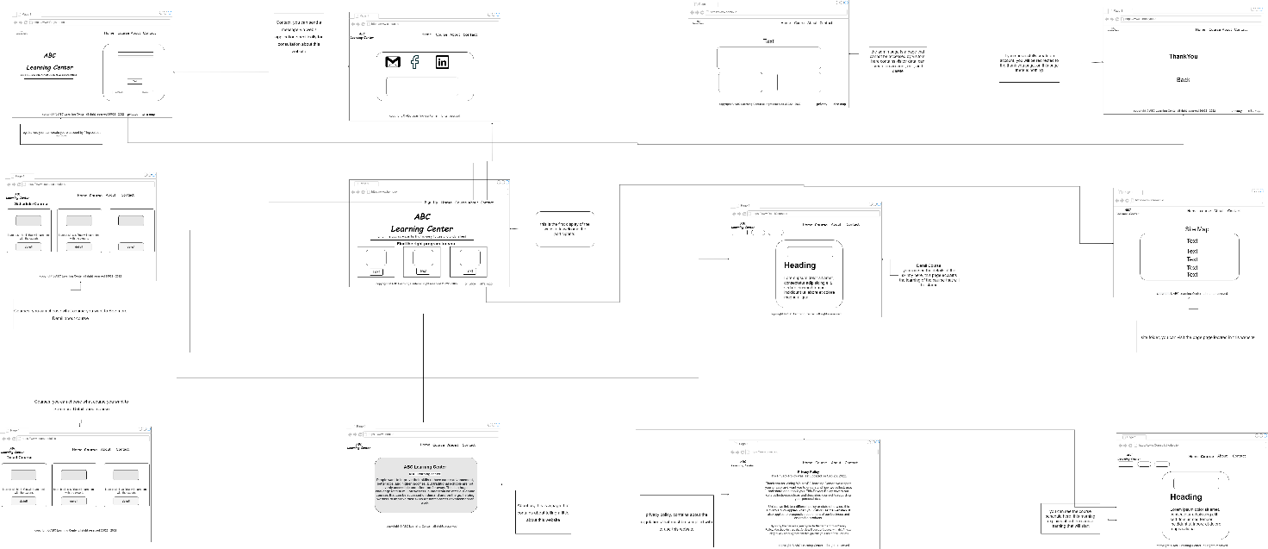

* Information arsitecture

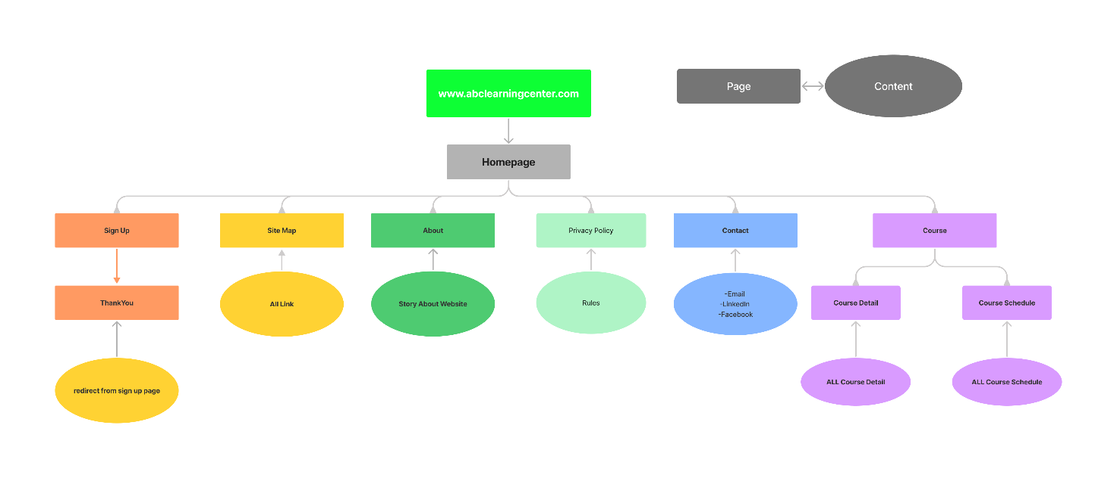

Task 3

Task Statement:

1. Develop the HTML Pages required for the website

2. Develop the Lead Generation Form & Administration System pages for Lead Generation form management.

3. Include the screen capture as part of Project Presentation

Solution:

* Sign Up

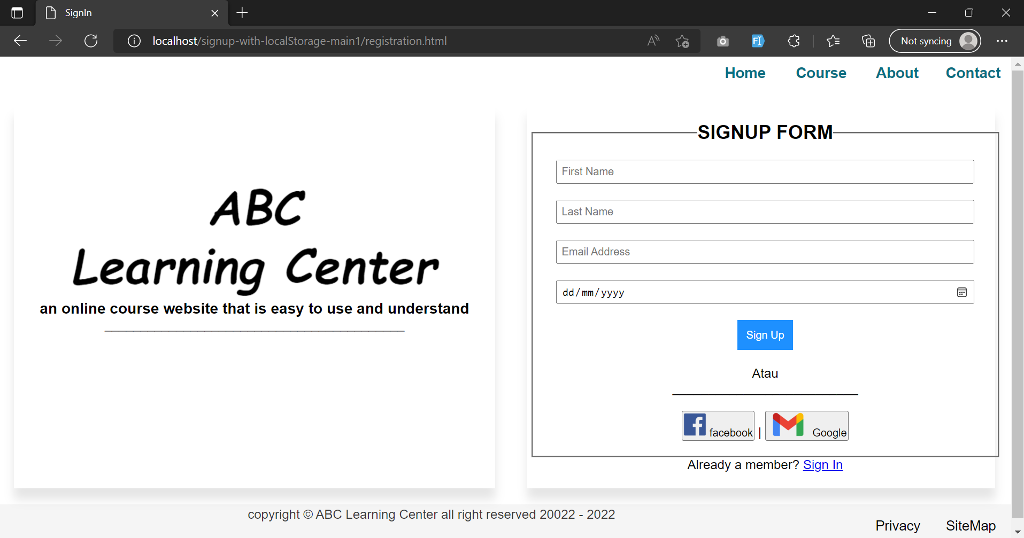

* Admin Page

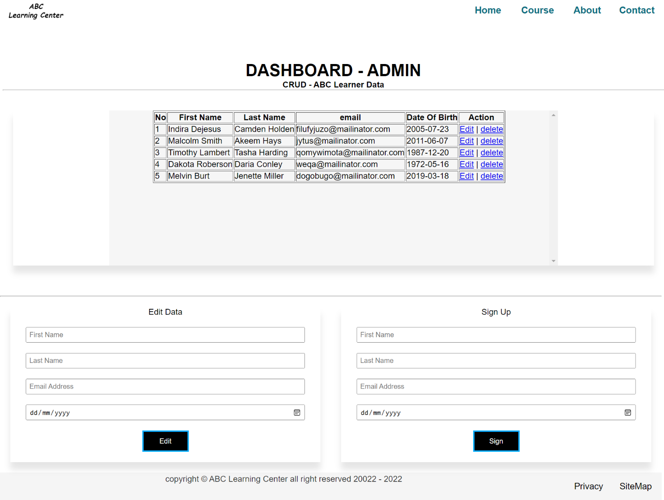

Task 4

Task Statement

1. Propose & use jQuery Components such as menu, popup etc as part of the website.

2. Design the required HTML for jQuery Components.

3. Provide screen capture as part of Project Presentation.

Solution

* For JQuery I use for dropdown course, and tabs Course

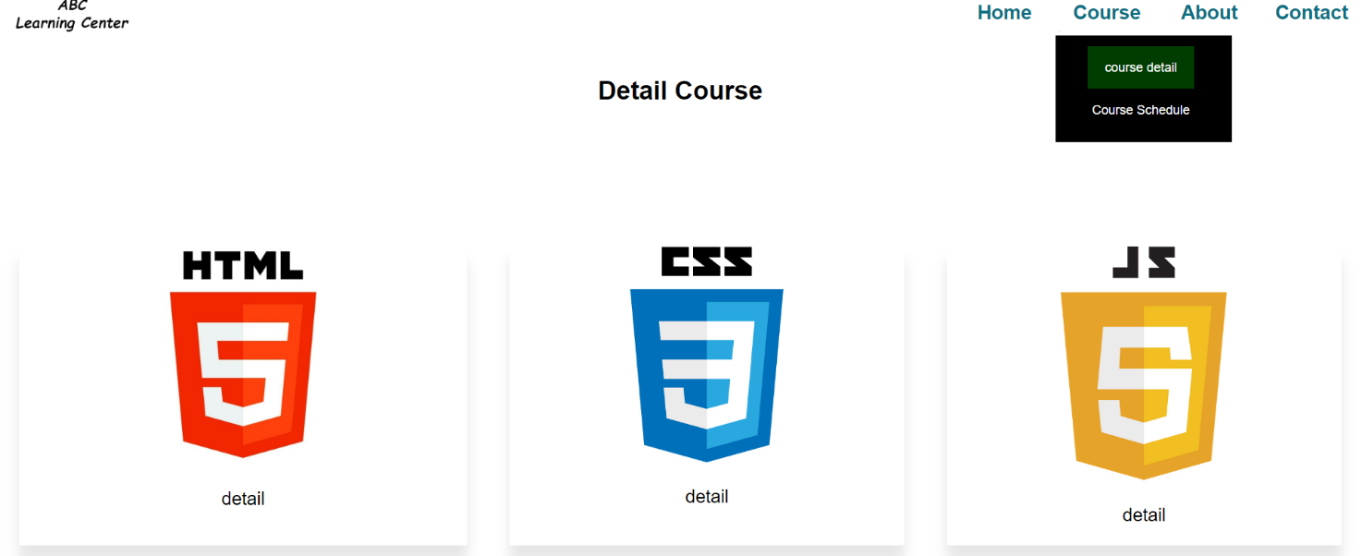

Task 5

Task Statement

1. Write a paragraph on the effectiveness of the designed Lead Generation Administration System. 2. Write briefly on effectiveness of the User interface according to 2 metrics

3. Include it as part of Project Report

Solution

My form should be able to alert the user on errors which they have made before submitting or proceeding. The errors should be displayed in such a way that it becomes easy for the user to find the error and rectify it. Hence it will enhance integrity of the data which we have received from the user.

2 metrics

1. Form validation-

Its is checking for valid email id and contact number.

1. Proper description of the error

Errors are displayed in a helpful way. So that it becomes easy for the user to debug and fill proper input.

Task 6

Task Statement:

1. Make changes to User Interface based on effectiveness metrics identified in Task 5.
2. 2. Make the changes to HTML, CSS & Javascript.

3. Include the screen capture along with list of modifications made as part of Project Presentation

Solution

2.can't duplicate

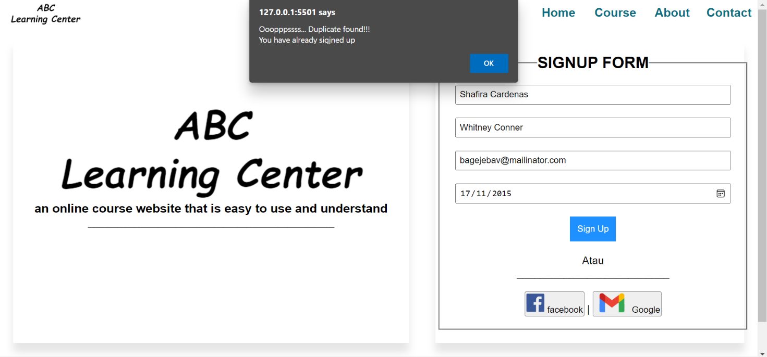

2.must include the @ symbol in the email

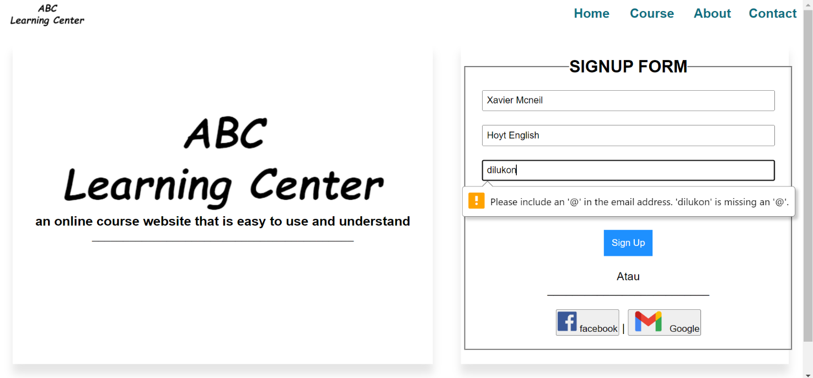

1. must fill out all forms

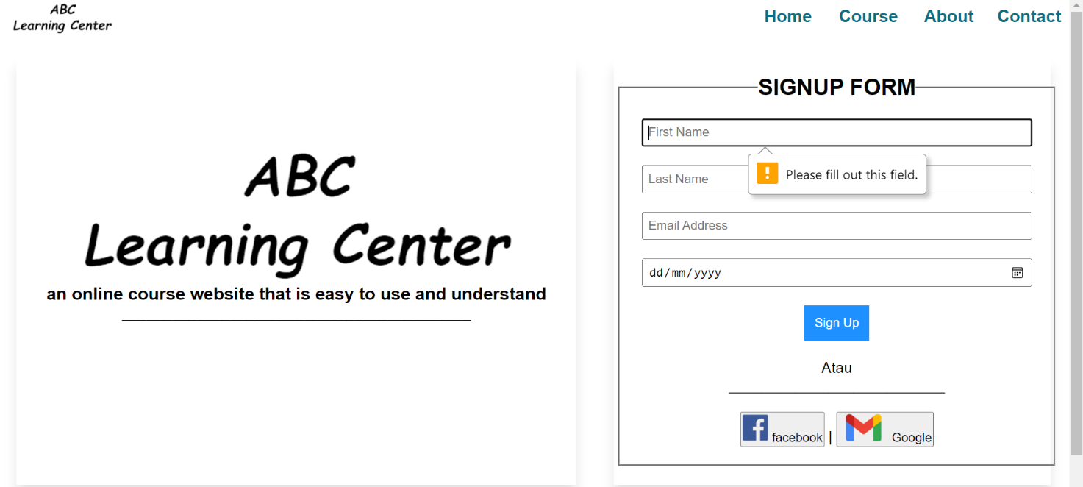

Task 7

Task Statement

1. Create a User Guide for Lead Generation form and its Associated Administration Module.
2. 2. Include it as part of Project Report

Solution

1.First type localhost/abc-learning-center/registration.html

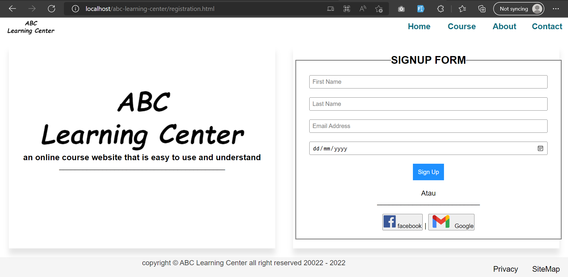

2.Must fill out all form

3.click Sign Up if youre done

4. then your data will enter the admin page admin page can only be accessed by the admin, users will not find the admin page in the site map

